**Experiment-2*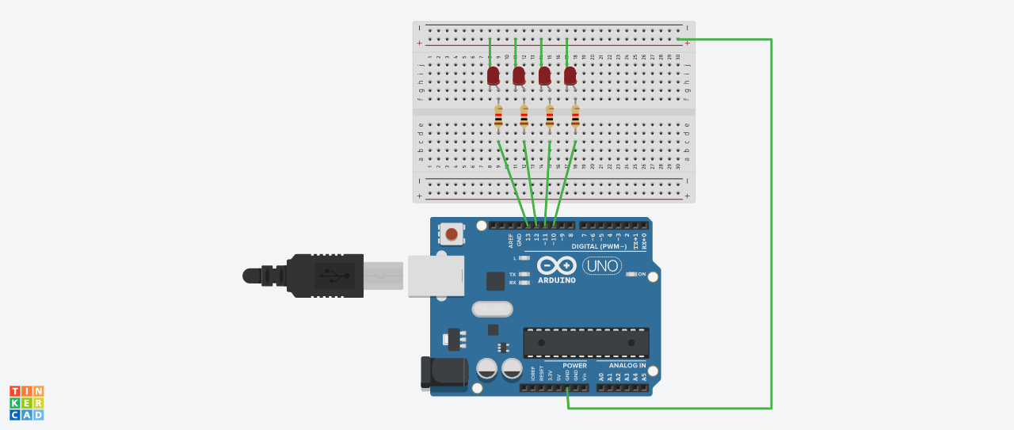***

***Concept used:***

In this experiment we will code and give instruction to glow led which is setted up on the breadbord.In this basic knowledge breadboard , wires and LEDs is used. Knowledge on arduino board and coding in arduino software is required . Understanding of simultaneously glowing LEDs is needed.

***Learning and observations:***

The coding is done using computer with the help of it the instructions are provided to the Arduino Uno board .Coding done on Arduino software is C++ . Arduino is a single-board microcontroller meant to make the application more accessible which are interactive objects and its surroundings.This micro controller gives the valid instruction to the elements fitted on the breadboard according to coding done on software.

Programming on arduino and importance of grounding is observed and also the more than one work can be done on arduino is also observed.

***Problems and Troubleshooting:***

1-The incorrect coding results in problems in the working of hardware. This can be corrected by learning C++ and practicing it on the software.

2-Hardware should be precisely fitted on the Breadboard or they might get fuse or get permanently damaged .

3-Arduino wire must be checked if they are loose or not. And the ports should be properly cleaned before using ,they might cause problem in future.

***Precautions:***

1-The coding done on the software should be acuurate.All the errors should be neglected i.e. syntax,logical errors etc..

2-All the wires and elements should be connected firmly and according to the coding done on the system.

3-Postive and Negative terminals should be put in their respective places.

4-Using safty measures.

***Learning Outcome:***

From this experiment we learned how to code in the software . This project was the base for the upcoming project we are going to do in upcoming semester.

In this project we learned how to flash a LED bulb and how to code it on the software.

Through this I gained the skill of coding in arduino softwareusing different methods in order to make the LEDs chasing .